1

CAMARILLO PONY BASEBALL

# ASSOCIATION 2025

BYLAWS

Prepared by:

The Board of Directors of the

Camarillo Pony Baseball Association

## Table of Contents

Article I. Guidelines for Parents, League Commissioners, Managers, and Coaches .................. 4

1. General Responsibilities and Behavior of Parents ............................................................. 4
   1. Requirements ................................................................................................................. 4
   2. Conduct .......................................................................................................................... 4
   3. Dealing with Managers ................................................................................................... 4
   4. Uniforms and Equipment ................................................................................................ 4
   5. Fund Raising .................................................................................................................. 5
2. General Responsibilities and Behavioral Standards of League Commissioners ................ 5
   1. League Commissioner’s Specific Responsibilities .......................................................... 5
3. Selection of Team Managers and Coaches ....................................................................... 5
   1. Team Managers ............................................................................................................. 5
   2. Team Coaches ............................................................................................................... 6
4. General Responsibilities and Behavioral Standards of Managers ..................................... 6
   1. Managerial Responsibilities ............................................................................................ 6
   2. Manager Behavioral Standards ...................................................................................... 7
5. Reasons and Procedures for Disciplining or Dismissing a Manager or Coach ................... 7
   1. Disciplinary Measures for Rules Violation or Misconduct ................................................ 7
   2. Procedures for Dismissal ................................................................................................ 7

Article II. Assignment of Players to Teams, Replacement, Reassignment, and Disciplining or

Transferring Players ....................................................................................................... 8

1. Assignment of Players to Quarter Horse & Shetland ........................................................ 8
2. Assignment of Players to Teams in all other Leagues ...................................................... 8 C. Player Draft Procedures ................................................................................................... 8 D. Roster Control .................................................................................................................. 9 E. Replacement and Reassignment ...................................................................................... 9
3. Acceptable Reasons for Disciplinary Action ......................................................................10
4. Notification of Disciplinary Action .....................................................................................10
5. Reasons for Removing a Player from a Game .................................................................10
6. Player Ejected from a Game ..............................................................................................10

Article III. Practice and Game Guidelines .................................................................................11

A. Practice Schedule ...........................................................................................................11 B. Game Schedule...............................................................................................................11 C. Game Rescheduling .........................................................................................................11

D. Protests ...........................................................................................................................12

1. Protest Board ................................................................................................................12
2. Protest Procedures ........................................................................................................12
3. Decision Time ................................................................................................................12
4. Game Replay Considerations ........................................................................................12
5. Game Replay Date ........................................................................................................12

Article IV. Post-Season Tournament, and Player Awards .........................................................13

1. Post Season Tournament .................................................................................................13
   * 1. Four Team Bracket ........................................................................................................14
     2. Five Team Bracket ........................................................................................................15
     3. Six Team Bracket ..........................................................................................................16
     4. Seven Team Bracket .....................................................................................................17
     5. Eight Team Bracket .......................................................................................................18
2. Player Awards ..................................................................................................................19
   1. Shetland,Pinto, Mustang, Bronco, Pony, and 18U Colt Divisions...................................19

3

* 1. Quarter Horse & Shetland…………………………………………………………………….19

## Article I. Guidelines for Parents, League Commissioners, Managers, and Coaches

### A. General Responsibilities and Behavior of Parents

Parents are the most influential of all CPBA members on conduct of players, managers, coaches and umpires. It is therefore vital to the success of this program for the parents to maintain good self-control at all times and express positive support for all participants.

The CPBA is a parent-supported organization. All parents must assist the league officers in attaining the objective of the CPBA.

1. Requirements

Parents will be expected to fill one of the following team support functions:

1. Manager or Coach
2. Team Scorekeeper
3. Team Field Preparation and Clean Up
4. Team Sponsor Liaison
5. Team Parent
6. Team Fundraising Coordinator
7. Team Yearbook Coordinator
8. League Yearbook Coordinator
9. League Parent
10. League Commissioner
11. CPBA Picture Day Support
12. CPBA Fundraising Support
13. Board of Directors Member
14. Conduct

The conduct of the parents when in contact with the team manager, coaches, players, and especially when at the games will be that of a responsible adult. Any parent or spectator who was ordered to be removed from the field area by the umpire, after one warning, is suspended from attending the remainder of that game. Penalty of up to three subsequent games may be applied upon review by the Board of Directors. Umpires shall submit a written report to the League Commissioner via the Director of Umpires. *Penalty:* If the suspended parent or spectator attends a game involving their team during the suspension period, the game may be forfeited to the opposing team at the discretion of the Board of Directors.

1. Dealing with Managers

Problems between parents, managers and/or coaches should first be discussed between the parties directly involved to attempt a resolution. If an issue cannot be resolved at this level, the manager should arrange a meeting between the parties involved and the League Commissioner.

If the issue is still not resolved, the parties should meet with the appropriate Director of

Commissioners and finally with the Board of Directors, if necessary. Failure to follow this plan will result in a denial of appeal.

1. Uniforms and Equipment

Parents and managers are responsible for the uniforms and equipment issued to players and managers. Equipment must be returned at the end of the season. If equipment is not returned, those responsible will be billed at the current rate of replacement and shall be excluded from further participation in the CPBA program until such bill is paid or the equipment is returned.

1. Fund Raising

All parents are responsible for making a reasonable effort to support CPBA fundraisers.

### B. General Responsibilities and Behavioral Standards of League Commissioners

Each League Commissioner supports the appropriate Director of Commissioners and shall be responsible for the organization and conduct of their league or league division.

1. League Commissioner’s Specific Responsibilities

1. Conduct an interview of all managerial candidates, which will be provided by the appropriate Director of Commissioners. At the conclusion of these interviews, compile a list of all applicants and present this final list of candidates to the Board of Directors for approval.
2. Review the Bylaws and submit any proposed changes in writing to the Board of Directors via the appropriate Director of Commissioners.
3. Attend the skills ratings for their respective leagues (Pinto – Colt).
4. Work with the Director of Equipment to coordinate the distribution (at the beginning of the season) and collection (at the end of the season) of equipment to team managers for their respective leagues.
5. Meet with team managers, as required, to keep managers apprised of league operation, schedule of events, and other important issues.
6. Attend the player draft.
7. After player draft, obtain and maintain current team rosters. Ensure that all roster changes are approved by the Director of Players before distributing to the managers.
8. Attend the proceedings for selecting the all-star players, managers and coaches.
9. Develop a preseason practice schedule for the assigned league.
10. After notification, in writing, by the team managers, approve and supervise disciplinary action of players.
11. If required, initiate disciplinary action or dismissal of managers and coaches as specified in the Bylaws.
12. Periodically inspect team scorebooks to ensure compliance with the Bylaws & Special League Rules.
13. Inform the Director of Umpires when umpires are late, do not report for games, or demonstrate less than acceptable conduct and skills in officiating or maintaining control of the game.
14. Provide assistance to the Director of Facilities in the upkeep of fields. This includes preparation, maintenance and clean-up assistance by using the League team personnel. It is the Commissioner’s duty to ensure that the managers oversee the cleaning of the dugout, field, and bleachers after all games and practices.
15. Submit request to reschedule games to the Scheduling Committee Chairperson via the appropriate Director of Commissioners.
16. Ensure managers obtain medical information sheets for each player and have them during all practices and games.
17. Maintain and post weekly league standings for Pinto, Mustang, Bronco, Pony, and Colt.
18. Assist board in providing field duty coverage.

### C. Selection of Team Managers and Coaches

1. Team Managers

1. Managers will be selected by the Board of Directors from a list of candidates provided by the League Commissioner.
2. All Managers must pass a background check and complete online concussion training.

2. Team Coaches

1. After the league player draft, the team manager will recommend a minimum of two coaches and submit their names to the appropriate league commissioner for approval by the Board of Directors within ten (10) calendar days.
2. All Coaches must pass a background check and complete online concussion training.
3. At least one coach should be a family member of a player on the team.
4. In the manager’s absence, one of the coaches will be the acting manager.

### D. General Responsibilities and Behavioral Standards of Managers

**and Coaches**

1. Managerial and Coaching Responsibilities

1. Teach each player the game of baseball and the meaning of playing together as a team.
2. Teach each player the meaning of good sportsmanship by precept and example.
3. Instruct and show by example good safety habits of practice and play.
4. Develop, to the best of his ability, the overall athletic skill of each player on the team.
5. Ensure his players’ parents carry out the work necessary for the team’s function. These job assignments are typically those of Coach, Scorekeeper, Sponsor Liaison, Team Parent, Field Preparation and Cleanup, Refreshment Coordinator, Team Yearbook Coordinator.
6. Provide a qualified scorekeeper, except in Quarter Horse and Shetland Leagues, for each scheduled game and be responsible for the submission of game scores to the League Commissioner.
7. Maintain discipline of the players, parents and spectators of the team at all practices and games.
8. Notify parents of practices and games.
9. Follow all aspects of CPBA’s “Concussion Protocol”
10. Ensure player and parent participation in keeping fields and areas around bleachers and dugouts clean. Failure of the manager to comply will warrant forfeiture of the game unless he or she lost, then the last win of that team may be forfeited.
11. Maintain a current record of player participation, e.g., games, innings played, innings pitched, etc.
12. Maintain order in the dugout by having a coach or self in the dugout at all times during play.
13. Be responsible for set-up or take down of the field when designated as the home team in the league schedule.
14. Ensure that equipment in his possession is in safe and usable condition.
15. Be accountable for his team’s equipment, which must be returned by the last scheduled turnin date. Failure to comply may result in a fine.
16. Notify the appropriate League Commissioner if an umpire is late or does not report for a game, or demonstrates less than acceptable conduct and skills in officiating or maintaining control of the game.
17. All 18U Colt, Pony, Bronco, Mustang, and Pinto Managers:
    1. No one other than players and Board approved Coaches and Manager are to be in the dugout during games. Other children of the Manager or Coaches, or siblings of the players are not allowed in the dugout under any circumstance.
    2. With the exception of Pinto Rec league (4), a maximum of three (3) Board approved Manager/Coaches are allowed on the field or in the dugout during any game.
    3. While on offense, there is to be only one third base Coach, one first base Coach. The remaining Coach or Manager is to be in the dugout or near the dugout entrance.

2. Manager and Coach Behavioral Standards

The manager, to exhibit proper behavior in the CPBA program, must:

1. Demonstrate good sportsmanship at all times.
2. Appropriately discipline players when necessary without attacking the player’s character.
3. Never imply, directly or indirectly, by action or comments that any particular player was personally responsible for the win or loss of a game.
4. Never solicit votes for an all-star team player or managing position prior to the all-star team or manager selection meeting.
5. Never use alcohol or tobacco products of any kind during games, or practices, or at any time while in contact with any CPBA player or CPBA player’s family.

### E. Reasons and Procedures for Disciplining or Dismissing a Manager or Coach

If a manager or coach is not discharging his responsibilities, he may be disciplined or dismissed only by approval of the Board of Directors.

1. Disciplinary Measures for Rules Violation or Misconduct

1. The League Commissioner, with approval of the Board of Directors may suspend managers and/or coaches for one game because of violations of the CPBA Bylaws & Special League Rules.
2. The League Commissioner shall notify the appropriate Director of Commissioners in writing of any violation and disciplinary action proposed.
3. A manager, coach or spectator ordered removed from the game by the umpire shall not instruct or manage his team for the remainder of that game. Penalty of up to three subsequent games may be applied upon review by the board of directors. During any suspension period, the Manager or Coach shall not instruct or manage his team in any manner from the stands or sidelines, including but not limited to, speaking with or giving instructions to players or fellow coaches on his team, or using any other member of his team or general public to communicate instructions to his players or fellow coaches. During his suspension, the Manager or Coach may conduct regular practices with his team, but may not manage or coach during any game, including pre-game warm-ups, as noted above.
4. The umpire shall submit a written report to the appropriate League Commissioner via the Director of Umpires, within 24 hours of ejection and in all cases at least 4 hours prior to the next scheduled game for the team in question. All appeals of suspensions must follow the same procedures as a protest. If sideline coaching, or umpire harassment continues, the manager, coach or spectator shall be subject to dismissal by the Board of Directors in addition to the forfeiture of the game.
5. Any manager, coach or spectator who inappropriately touches or exhibits inappropriate behavior with or toward an umpire or League Official may be suspended for the balance of the season, subject to an appeal, if any. The umpire shall submit a written report within 24 hours to the Director of Umpires. The manager, coach or spectator shall also submit a report in writing within 24 hours to the appropriate Director of Commissioners. The Board of Directors shall review the matter.

2. Procedures for Dismissal

1. The League Commissioner shall first discuss the violation with the manager and/or coach and attempt to correct the violation.
2. If the League Commissioner is unable to correct the violation, the manager and/or coach will then, together with the League Commissioner, meet with the appropriate Director of Commissioners in a further attempt to resolve the violation.
3. If it becomes necessary, the Director of Commissioners and the League Commissioner will bring the manager and/or coach before the Board of Directors.

## Article II. Assignment of Players to Teams, Replacement, Reassignment, and Disciplining or Transferring Players

**All players will be assigned to their age appropriate league. However, with Board approval, a player may be permitted to play down from his or her age appropriate league if the board deems it to be in the best interest of the player with regards to skill level and safety. The board reserves the right to re-assess and reassign said player to his or her age appropriate league at any time.**

### A. Assignment of Players to Quarter Horse & Shetland

1. When assigning players to teams, parity is the main objective. The Director of Players will attempt to form and assign all teams in Quarter Horse & Shetland using geographical location of players. Team assignments will include the manager’s son or daughter unless otherwise requested. The number and ages of players on each team will be at the discretion of the board.

### B. Assignment of Players to Teams in all other Leagues

The Pinto, Mustang, Bronco, Pony and 17U leagues will each have one league.

1. The Board of Directors will determine the number of players on a roster based upon therecommendation of the Director of Players.
2. All proposed managers shall attend the skill ratings for his league and rate each player. A panelconsisting of Board Members and qualified volunteers will also rate all players. These scores will be used as an additional source of information.
3. The parent of a player may request in writing that a particular manager not select his child. Onlyone (1) request will be considered and it must explain the reason for the request. This request cannot be used in an attempt to increase the probability of being selected by a more preferred manager. The request must be provided to the Board of Directors President or his designee 48 hours prior to any draft. The President with two other Board Members will approve or reject the request. If approved, the affected manager will be informed prior to the draft.
4. The teams will be formed using the player draft procedures.
5. The number and ages of players on each team will be at the discretion of the board.
6. Any player not attending Skills Ratings will not be eligible to be drafted.
7. Upon completion of the player draft, players who did not attend Skills Ratings will be assigned to a team in a random fashion that will be determined by the Director of Players.

### C. Player Draft Procedures

In selection of players, the basic goal of CPBA is to achieve league balance.

1. At least 48 hours prior to the draft, the appropriate league commissioners will make available to all managers a list of all eligible players. This list will be obtained from the appropriate Director of Players.
2. A Board Member will be responsible for the draft proceedings.
3. The appropriate Director of Players and appropriate Director of Commissioners shall assist the Board Member and serve with him as a three member Team Formulation Review Committee to resolve any unforeseen problems.
4. No one other than Managers, League Commissioners, and Board Members shall be allowed at any draft proceedings.
5. The manager’s child shall be drafted in his / her natural round based upon the player’s skills rating.
6. In the event the manager has more than one child, each child will be selected in his / her natural round.
7. In the event the manager’s child did not attend skills ratings, the player will be selected in the earliest round possible.
8. A manager’s assistant coach’s child will be selected in its natural round based upon the skills rating. If the player did not attend the skills rating, then the player will be selected in the earliest round possible*.*
9. Based upon the Board’s relative rating of the managers’ children, the order of draft selections will be determined prior to Round 1. The manager with the lowest rated child shall have the first opportunity to choose his position for Round 1, either A, B, C, D, E, or F, in a six team serpentine draft. The manager with the next lowest rated child shall choose his position next, and so on until all Managers have been positioned. A chart, showing the serpentine draft order will be provided, with the Manager in position A making the first selection in Round 1, the Manager in position B making the second selection, the Manager in position C the third selection, the Manager in position D the fourth selection, the Manager in position E the fifth selection, and the Manager in position F the sixth selection. In Round 2, the process reverses, with position F making the first selection, position E making the second selection, and so on until the Manager in position A makes the sixth selection in Round 2. The process continues to reverse itself each round until the draft is concluded.
10. All players that have attended skills ratings will be drafted prior to those who did not attend tryouts.
11. At the conclusion of the player draft, the undrafted players will be randomly assigned to a team.
12. A manager without an automatic draft pick will choose a player whose value is equal to or greater than the average of the ratings of the other players in the automatic draft as his first round selection.
13. The sibling of a selected player will be automatically drafted to the same team during their natural round, based upon the ratings of the panel, unless specified by the parents.
14. After all rosters are full, each manager may initiate ONE trade and be involved in no more than two trades. The Director of Players or his designee must approve all trades. All trades must occur at the draft.
15. All Managers are to attend the Draft selection meeting.

### D. Roster Control

1. In the Rec League, Managers will maintain a full roster as determined by the Board of Directors, and as long as replacement players are available on the waiting list. Injured or sick players who are expected to resume playing before the conclusion of the season may be retained on the roster.
2. Managers must immediately notify the League Commissioner of any player who might not resume playing before the conclusion of the season. The League Commissioner will notify the appropriate Director of Players.
3. All proposed changes in a team’s roster shall be communicated to and approved by the Board of Directors, prior to said change takes place.

### E. Replacement and Reassignment

1. When a Rec League Roster opening occurs, the manager in need of a replacement player will notify the Director of Players. A roster opening is deemed to occur when a player is not expected

to return to his team. No Manager or Parent may contact any prospective replacement player or their parent(s). The Director of Players will contact the parent’s of the next player on the wait list, as well as the League Commissioner. Immediately upon acceptance by the prospective replacement player’s parent(s), the Manager is then permitted to, and shall, contact that player and invite him to the next practice and arrange for a proper uniform. A final decision by the replacement player’s parent must be made before the team’s next game. ABL teams are not permitted to add a player that is on an active Rec League roster.

1. Players who are added from the wait list to a Rec League team will be eligible for all-star play if the move happened before the halfway point of the season.

### F. Acceptable Reasons for Disciplinary Action

1. The manager has the responsibility of maintaining a high standard of behavior among the players on the team. If the manager feels that a player is behaving in a manner not consistent with good sportsmanship or not in the best interest of the team, he or she may request, through the League Commissioner, that the appropriate Director of Players remove the offending player from the team roster.

### G. Notification of Disciplinary Action

1. A player shall not be benched for disciplinary reasons such as missing practice, being late for practice or other “non-game” reasons until the League Commissioner has been notified and given his approval. The League Commissioner will then notify the appropriate Director of

Commissioners. The appropriate Director of Commissioners may act in the place of the League Commissioner if the latter is unavailable.

### H. Reasons for Removing a Player from a Game

1. If it is the opinion of the manager that a player’s participation in a game may result in injury either to himself, or to another, that manager may, with the concurrence of the umpire, remove said player from the game. The umpire must make note of any player removals in the affected team’s scorebook. There is no penalty unless the affected player’s team falls below nine (9) players, at which time an out will be recorded for the removed player in his spot in the batting order for the first time only.
2. Subsequent missed at-bats by the removed player will be skipped and no penalty will be assessed.
3. A player who has left the field has a grace period of 60 seconds after he has been called to the batter’s box to return to the field. If the player fails to return before the end of these 60 seconds, the player will be called out, but may return to the line-up in the same batting order.
4. A player who has left the complex for any reason will not be recorded as an out, but may not return to the line-up at any point during the game. However, if the removal of a player causes the team to fall below 9 players, an out will be recorded for the first missed at-bat only.

### I. Player Ejected from a Game

1. A player ejected from a game by the umpire is suspended for the remainder of that game.

Penalty of up to three subsequent games may be applied upon review by the Board of Directors.

1. The umpire shall submit a written report to the Director of Umpires within 24 hours. The Director of Umpires shall forward a copy of the ejection report to the League Commissioner prior to the Ejection Board convening.
2. A suspended player may attend the game as a spectator only. If a player is found to have violated the suspension, the game in which the violation occurred will be forfeited at the discretion of the Board of Directors.
3. In the event of an ejection, the ejected player’s spot in the batting order will be recorded as an out in all subsequent at-bats; as well as that at-bat, if the ejection occurs while the player is batting.
4. All ejections shall be evaluated by the Ejection Review Board to determine disciplinary actions and suspensions. The board is comprised of Director of Umpires (Chairman), President, and Vice President. The board may invite the Director of Commissioners, Director of Players, and/or League Commissioners involved to determine the appropriate actions against such player. The board shall make every effort to convene prior to the next scheduled game of the ejected player.
5. If any member of the Ejection Board manages or coaches a team, and is involved in the ejection, the appropriate Director of Commissioners will act on the Ejection Board in their place.

## Article III. Practice and Game Guidelines

### A. Practice Schedule

1. Pre-season practices may not exceed three per week with a maximum practice time of two hours per practice. Pre-season practices may be adjusted with the approval of the Board of Directors.
2. During the season, the combination of games and practices may not exceed four per week.

### B. Game Schedule

1. The Scheduling Committee is responsible for having a game schedule prepared and distributed to each League Commissioner. The League Commissioner is responsible for distributing the schedule to each manager. Each manager is responsible for distributing the game schedule to each player on his/her team.

### C. Game Rescheduling

1. All games schedules are final when distributed. Games will not be rescheduled except for reasons of weather, field conditions, schedule errors, or if the Board of Directors determines a change would benefit CPBA. Requests to reschedule games must be submitted by the League Commissioner to the appropriate Director of Commissioners at least 48 hours prior to the original scheduled game time. The Scheduling Committee will approve or disapprove the requested schedule change. If the schedule change is approved, the Scheduling Committee chairperson will provide the revised written schedule to the appropriate Director of Commissioners and Director of Umpires. The appropriate Director of Commissioners will provide the revised schedule to the League Commissioner. The League Commissioner will notify the team managers. The board reserves the right to reschedule games as needed when time does not permit per Game Rescheduling procedures.

### D. Protests

A manager may protest a game after he perceives that the umpire has misinterpreted a rule against his team. Protests based on judgment decisions by the umpire are not permitted.

1. Protest Board

a. The Protest Board will consist of the Director of Umpires (Chairperson), Director of

Procedures, the appropriate Director of Commissioners, the President and Vice President. At least five members of the Protest Board must be present to render a decision. In the event the Protest Board is unable to convene five members, the appropriate League Commissioner will act as a Protest Board Member for the protest then under consideration on a temporary basis. The appropriate League Commissioner will attend all Protest Board meetings, participate in all aspects of the meeting, but shall only have the power to vote on any protest in the event that he or she is duly called to act as the fifth Protest Board Member. The Protest Board shall concern itself only with the game being protested and may solicit testimony from any source that it chooses, but actual decisions shall be based on majority vote. Decisions of the Protest Board are final, are not subject to appeal, and will be submitted to the Secretary for recordation purposes.

1. Protest Procedures
2. When a protest occurs, the objecting manager must, at the time of the play, notify the plate umpire, the opposing manager, and the official scorekeeper that the game is being played under protest.
3. Any team manager or other adult leader who withdraws a team from the playing field under any circumstances prior to the official completion of the game shall forfeit all rights to protest as described above.
4. Umpires should make a public announcement to the crowd when a game is being played under protest.
5. The umpire shall submit a written report immediately.
6. The protest must be submitted in writing within 48 hours of the completion of the game to the

Protest Board in care of the Director of Umpires. A check for $100.00 payable to the Camarillo Pony Baseball Association must be included. If the protest is upheld, the check will be returned. If the protest is not upheld, the money will become part of the CPBA treasury.

1. Decision Time

a. The Protest Board will make every effort to render a decision within five calendar days of the receipt of the protest from the protesting manager.

1. Game Replay Considerations
2. Any game in which a protest is upheld will be replayed from the point of the protest with each team having the same lineup in effect at the time of protest. Pitchers’ eligibility shall be determined by the number of innings pitched during the game at the time of protest.
3. In leagues using round-robin batting and free substitution, the lineup will remain intact except that an absent player may be deleted from the lineup.
4. Game Replay Date

a. If a protested game is replayed, it will be replayed as soon as possible. The Scheduling Committee shall schedule replayed games.

## Article IV. Post-Season Tournament, and Player Awards

### A. Post Season Tournament

The Pinto, Mustang, Bronco, Pony, and 18U Colt leagues shall have a post-season double elimination tournament in which all teams participate. Seeding of the teams in the tournament will be based on the results of the league games. Leagues with more than eight (8) teams will be divided into two divisions: American and National.

1. We will be using team record of wins and losses. If there is a tie in the league standings, the head-to-head results will be used. If this does not result in a champion, the following tiebreakers will be used. Only league games between the tied teams will be considered. a. Least runs scored against

1. Most runs scored
2. A coin toss

Pinto and Mustang leagues will play a minimum of 4 innings for tournament games. The championship game will be played in full (6 innings) but the mercy rule still applies.

Bronco will play a minimum of 5 innings for tournament games. The championship game will be played in full (7 innings) but the mercy rule still applies.

Once the minimum innings limit is reached, games will conclude in accordance with that league’s established time limit.

If it is determined that a coach is purposefully delaying a game, he / she will be subject to disciplinary action.

Board members will be present on site during playoffs in case a game time decision needs to be made in order to keep the game going.

The top seed will be HOME team in all tournament play with the exception of Championship game. If top seed in the Championship game comes from the losers bracket, the top seed would be the visiting team. If the “If Necessary” Championship game needs to be played, the top seed will be HOME team.

The following are the tournament brackets to be used:

**FOUR TEAM BRACKET**

**Double Elimination Tournament**

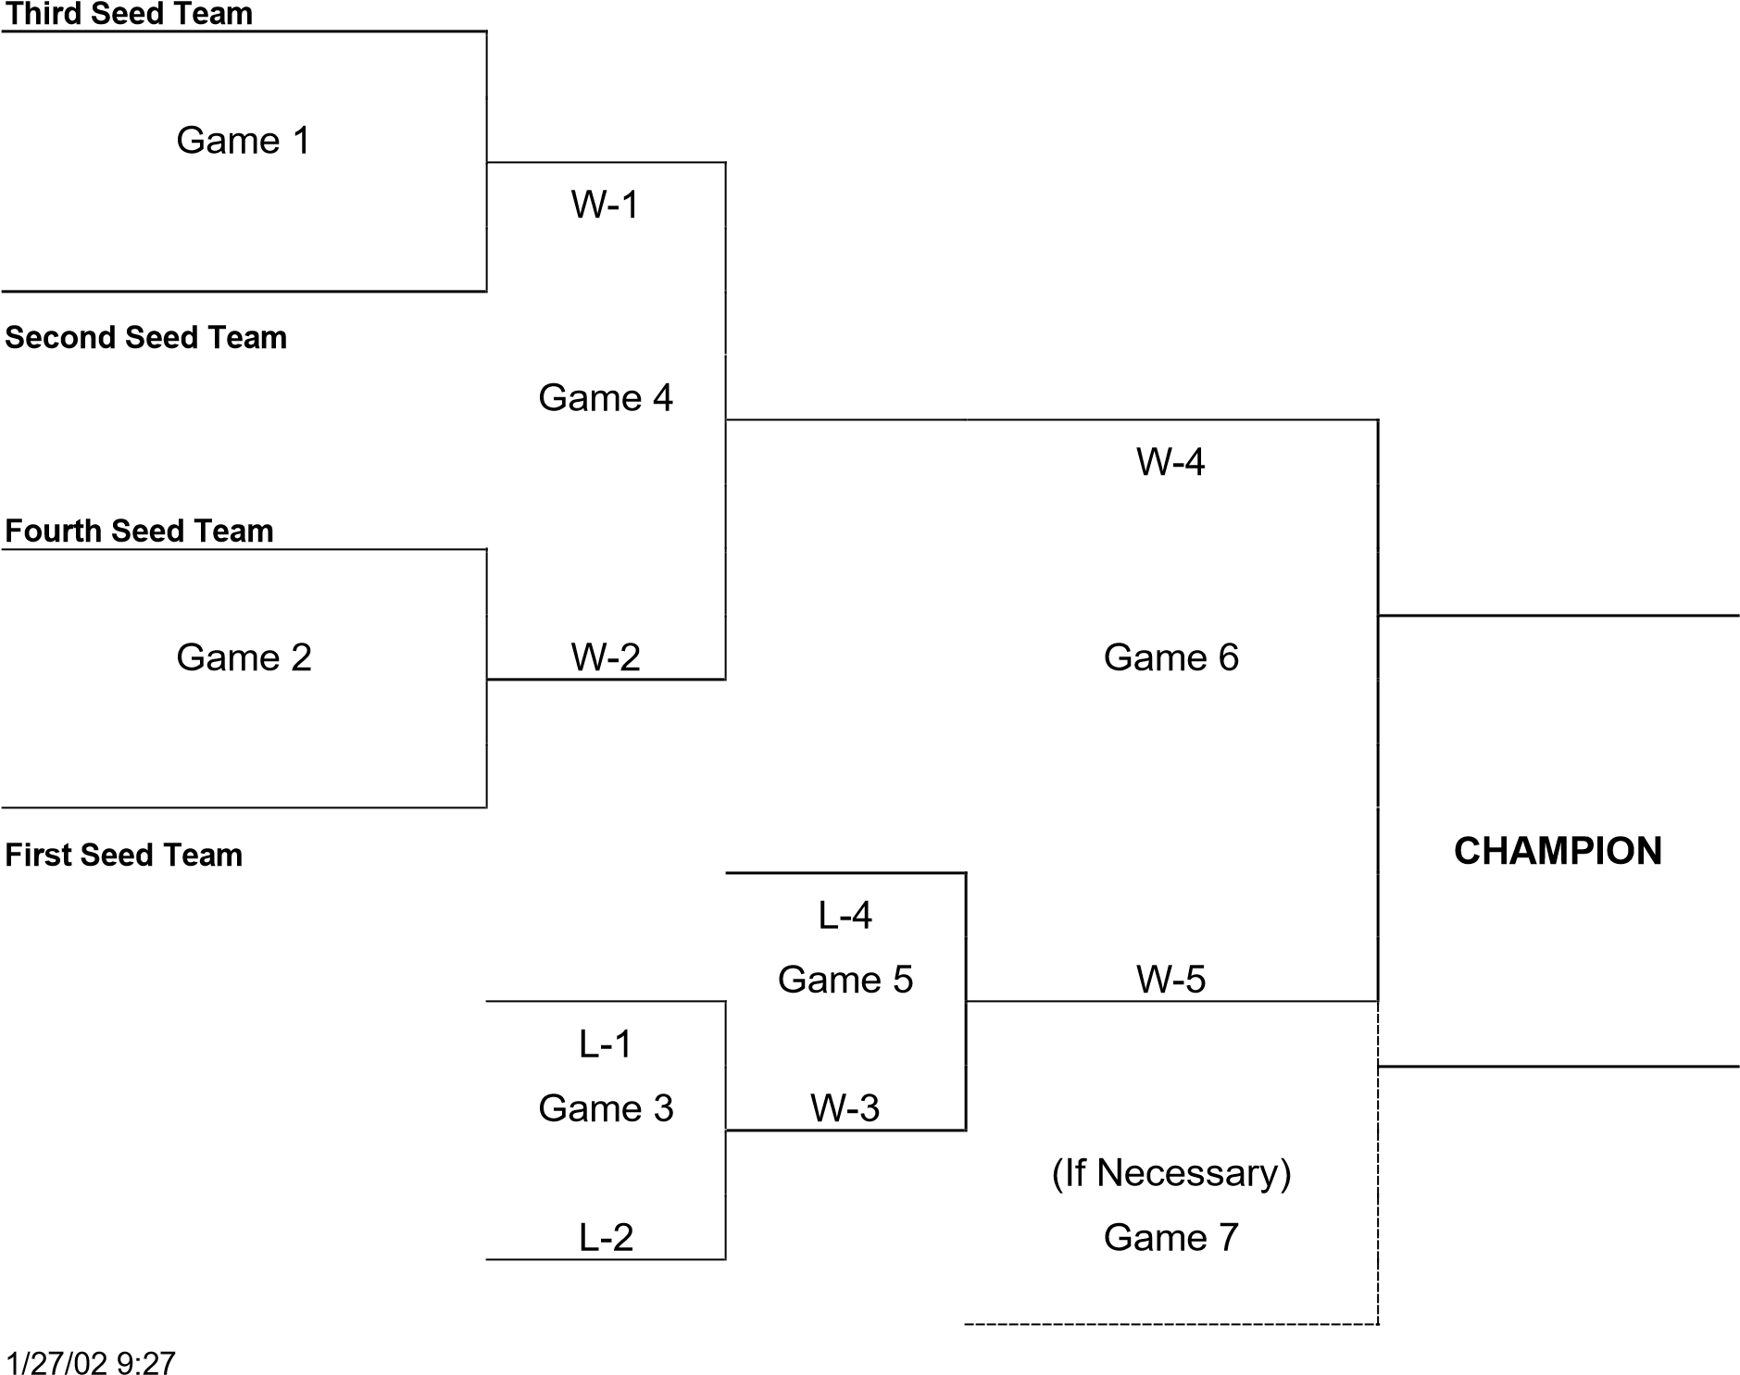

**FIVE TEAM LEAGUE Double Elimination Tournament**

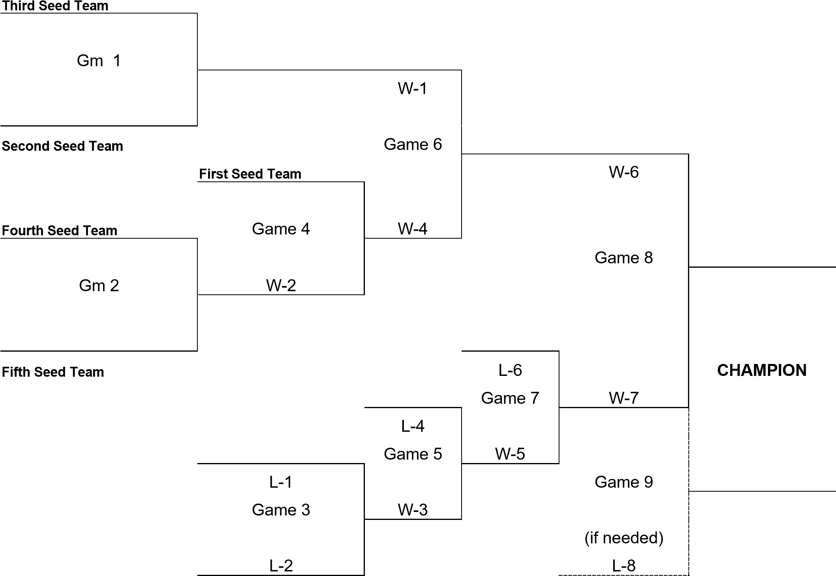

**SIX TEAM LEAGUE Double Elimination Tournament**

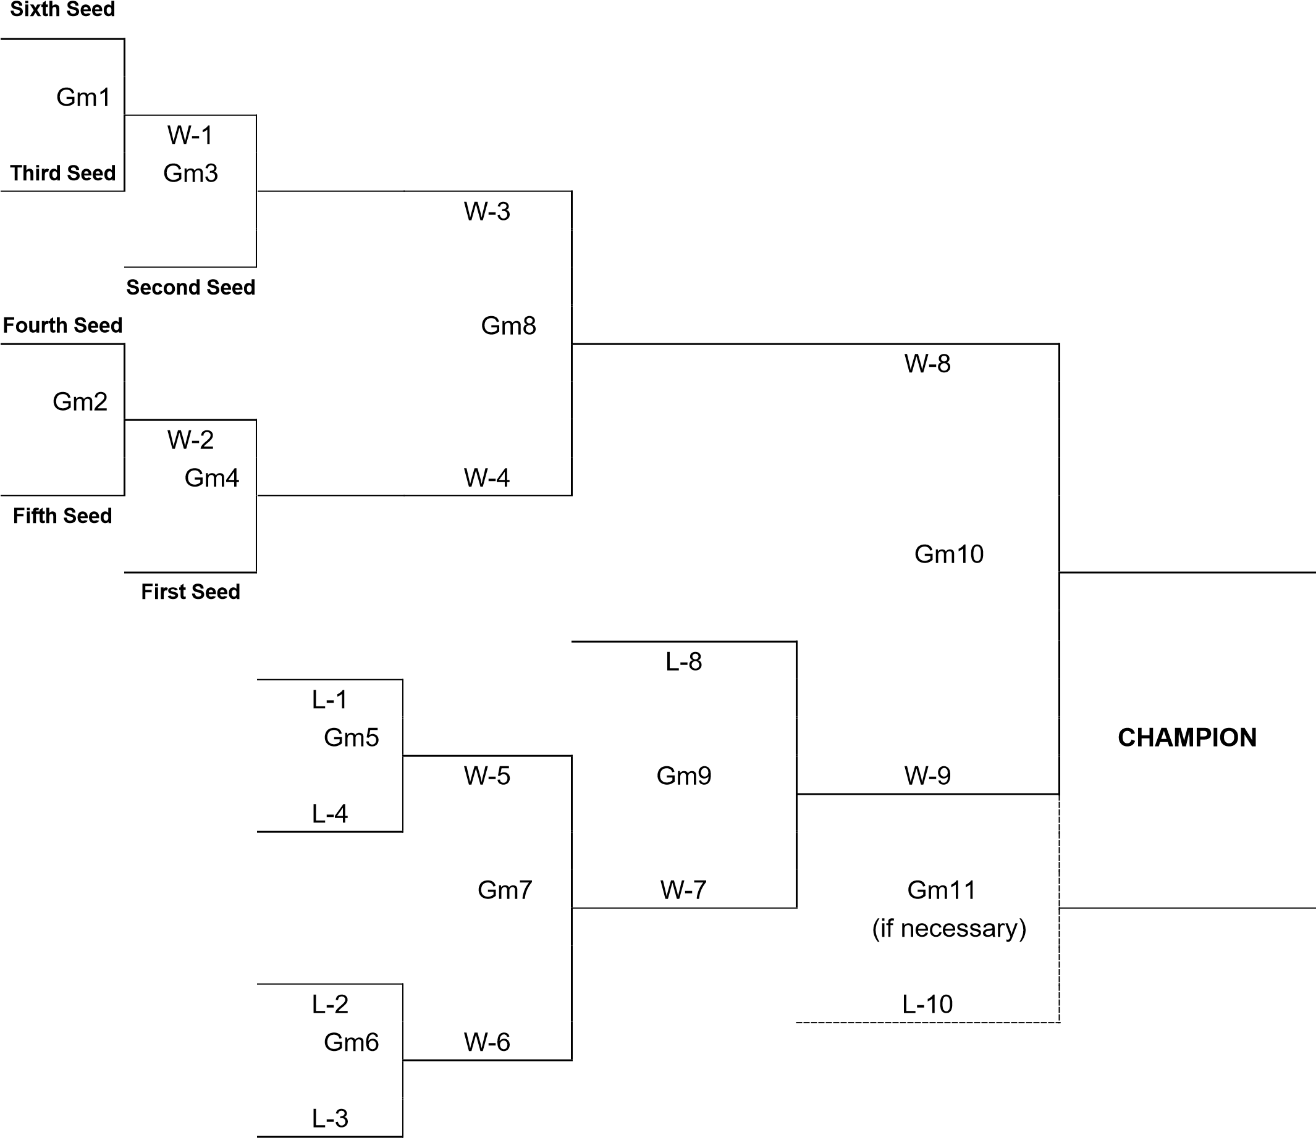

**SEVEN TEAM LEAGUE**

**Double Elimination Tournament**

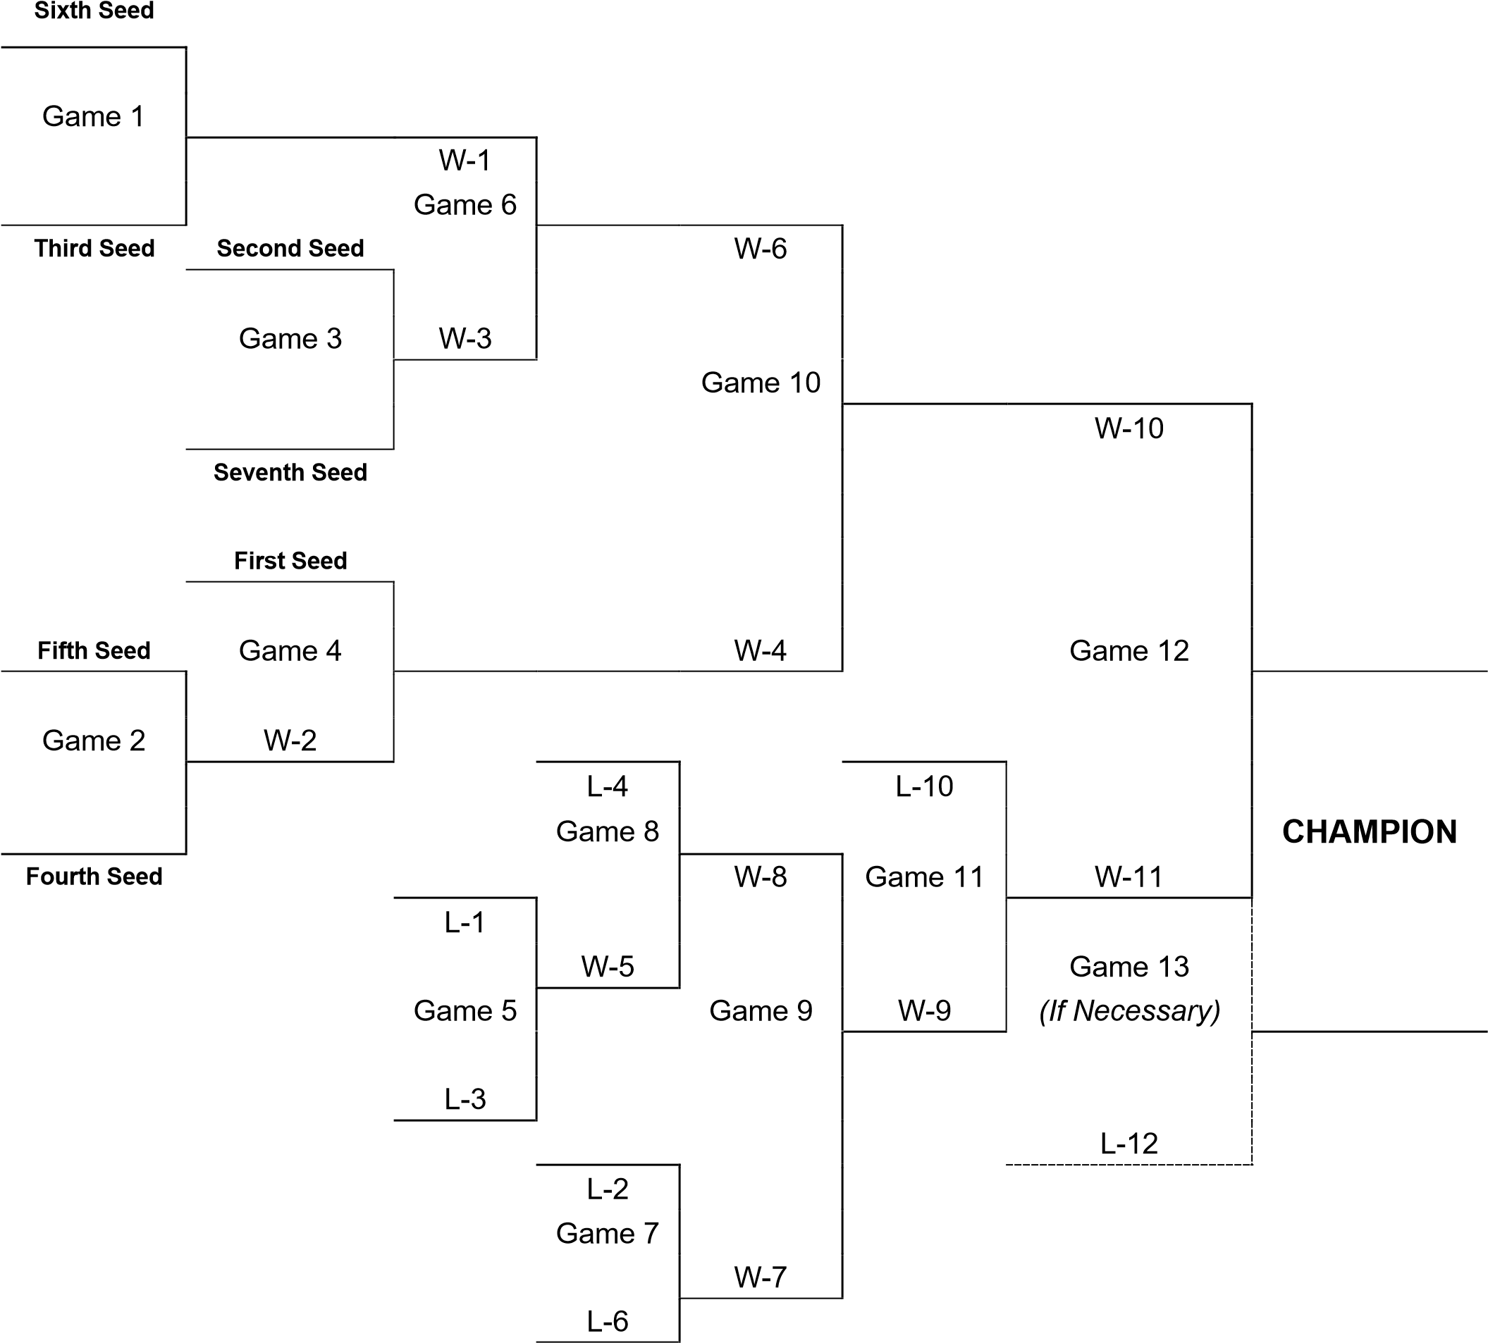

**Eight Team League Double Elimination Tournament**

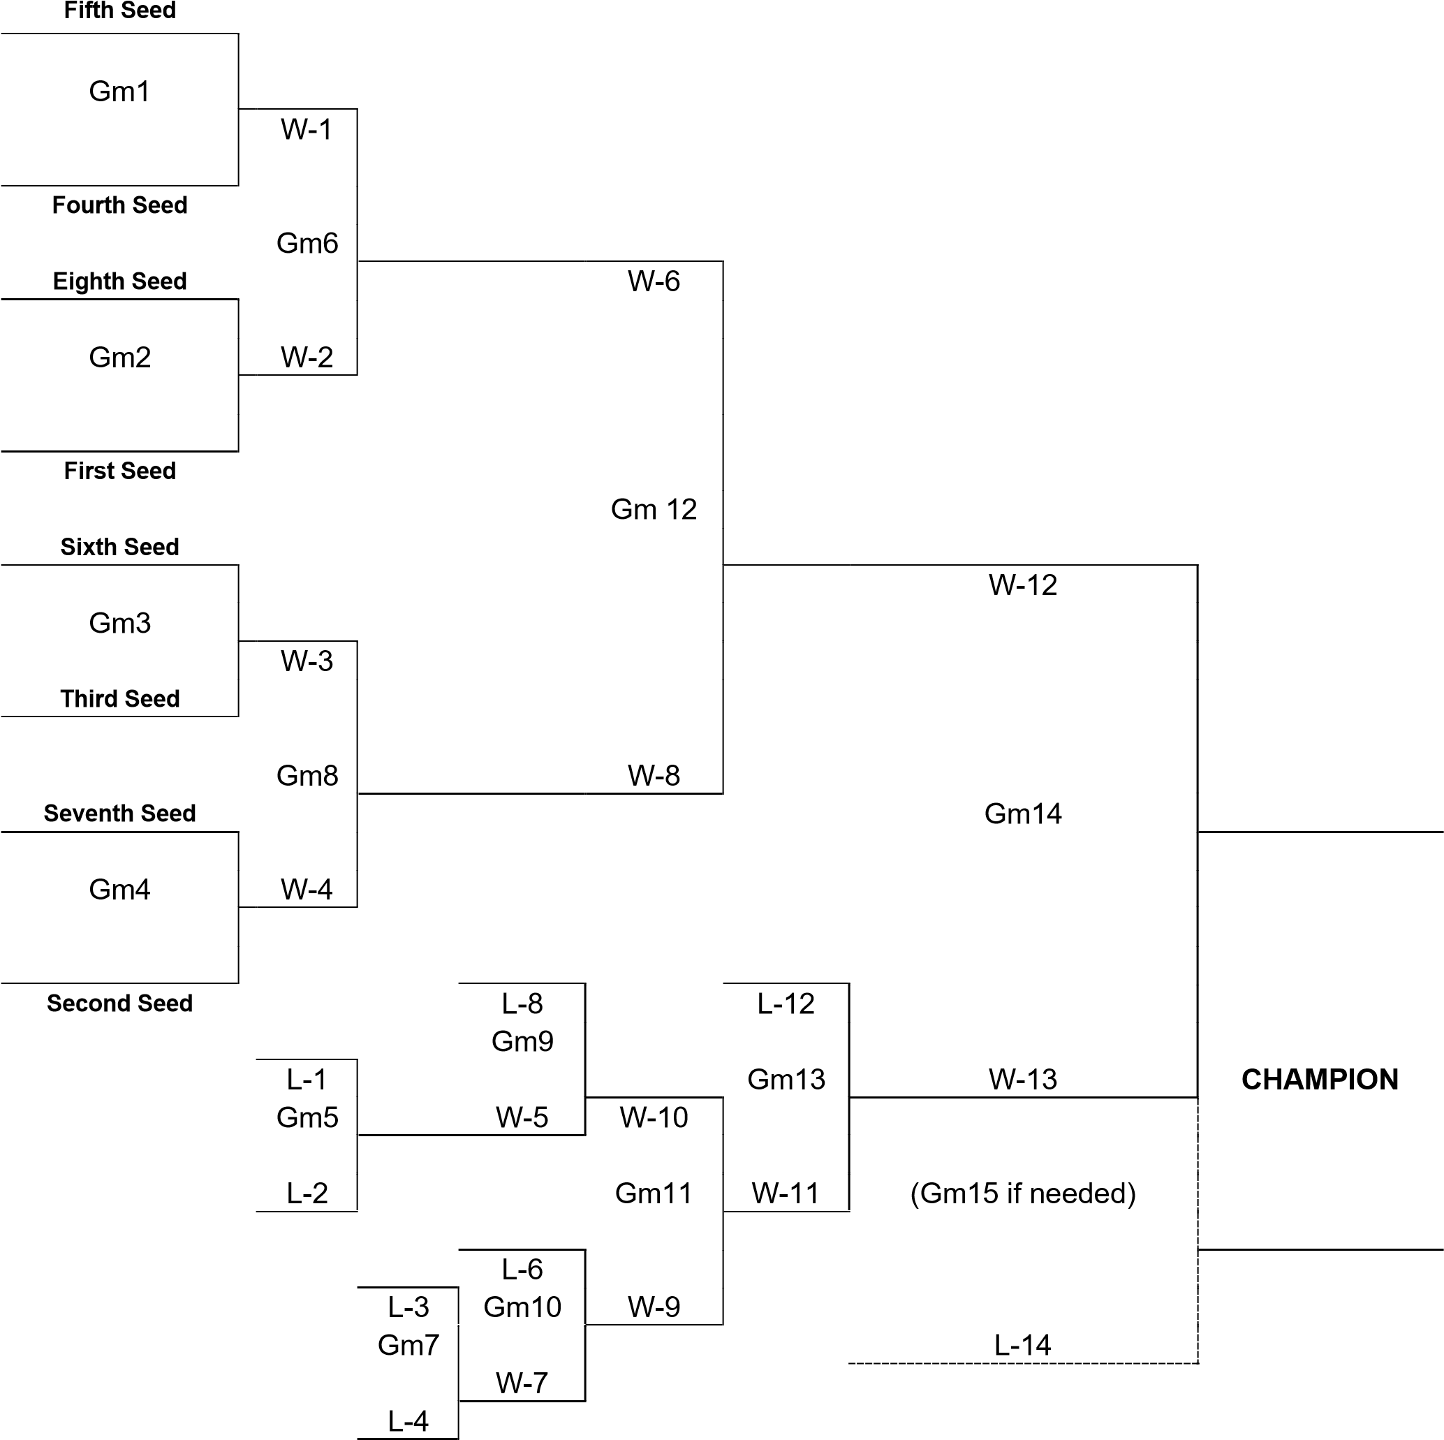

### B. Player Awards

1. Pinto, Mustang, Bronco, Pony, and 18U Colt Divisions

a. The team finishing with the best record, or in the case of equal records, the team with the best record in head-to-head league games, shall be declared the league champion. If this tiebreaking procedure does not yield a single champion, each such team will be declared cochampions. Each player on a championship team will be given an award. Other awards are at the discretion of the Board of Directors.

2. Shetland and Quarter Horse

a. League standings will not be compiled and all players will receive participation awards.